Machine Learning Based Predictive Model for Urban Livability Using Environmental and Socioeconomic Indicators
Aakarsh Pab  Dept. of Computer Science  Amity University  Noida, India | Sagar Singh Bisht  Dept. of Computer Science  Amity University  Noida, India | Dr. Shuchi Mala  Dept. of Computer Science  Amity University  Noida, India

Abstract— The increase in urban migration in India has raised the need for residential decision tools that are based on data. This research article introduces CityMatch, a Delhi-based neighbourhood recommendation system that uses machine learning to measure the quality of life in 72 urban neighbourhoods through six different data sources: seasonal PM2.5 air quality indices (CPCB), real-time traffic congestion profiles (TomTom Flow API), 2BHK rental prices (5,902 Kaggle listings), and geospatial densities of schools, hospitals, and metro stations within a 1km radius extracted using OSMnx. The methodology incorporates MinMaxScaler normalization coupled with 95th-percentile capping to reduce distortions caused by geographical outliers, then K-Means clustering (K=4, Silhouette Score=0.41) is used to divide neighbourhoods into four statistically different liveability classes. A scoring method that combines a weighted sum with directional feature inversion translates user preference weightings into an instant Match Score, accessible through an interactive Streamlit dashboard. Tests reveal that this tool not only highlights budget-friendly and high-end neighbourhoods in line with market truths, but the cluster descriptions also provide understandable urban liveability models that can be utilized for future city-scale developments.

Keywords—neighbourhood recommendation; K-Means clustering; liveability index; geospatial analytics; urban computing; OSMnx; TomTom API; Streamlit; Delhi; smart city.

I. INTRODUCTION
The rapid growth of Indian cities has produced a notable imbalance in the availability of information for the potential city dwellers. People moving to urban centres such as Delhi face the challenge of assessing many localities on multiple aspects like cost, quality of environment, security, and ease of access, a multi-criteria decision problem that is at present solved through informal word-of-mouth, real estate agents, or fragmented online listings. There is absolutely no systematic, data-driven instrument available to measure and equate the neighbourhood liveability in the context of Indian cities.
Neighbourhood recommendation systems have been studied extensively in Western urban contexts [1]– [3], leveraging census data, walkability indices, and property databases. However, Indian cities present unique challenges: heterogeneous data availability, sparse official statistics at the sub-district level, and liveability factors specific to the local context such as PM2.5 air pollution (a critical health concern in Delhi), distance to metro stations as the primary commute infrastructure, and proximity to private schools and hospitals as markers of neighbourhood quality.
This paper makes the following contributions:
- A reproducible multi-source geospatial pipeline for 72 Delhi neighbourhoods integrating real-time traffic, seasonal AQI, rental market, and amenity data.
- A K-Means clustering framework identifying four statistically distinct urban liveability tiers with interpretable cluster profiles.
- A weighted sum recommendation engine with directionally corrected feature scoring deployed as an interactive Streamlit application.
- A critical evaluation of data quality challenges in geospatial ML pipelines, including OSMnx tagging noise and API temporal sampling strategies.
II. RELATED WORK
Neighbourhood quality assessment has a long history in urban informatics. Early work by Sampson et al. [1] established the concept of neighbourhood effects the idea that residential context independently influences individual outcomes beyond personal characteristics. Quantitative operationalisation of this concept has accelerated with the availability of large-scale geospatial datasets.
Venerandi et al. [2] proposed a street-level imagery approach to urban deprivation detection using convolutional neural networks on Google Street View data. While achieving high accuracy, this approach requires substantial computational resources and is limited to areas with dense imagery coverage — a constraint that excludes peripheral Delhi neighbourhoods.
Real estate recommendation systems have been concentrating on matching at the property-level [3], [4], i.e. collaborative filtering and content-based methods on the features of the listings. Contrary to this, CityMatch works at the neighbourhood level and incorporates environmental factors (AQI, traffic) along with market data, which is more consistent with residential satisfaction in the long term than features of the property alone.
Zheng et al. [5] have investigated the incorporation of air quality into recommendation systems for cities through the example of Beijing and have shown that the residential attractiveness at the sub-district level can be distinguished substantially on the basis of PM2.5 variation. Our seasonal decomposition method is an improvement as it also considers the monsoon-winter pollution pattern of the Indo-Gangetic Plain.
As far as we know, no one has combined real-time traffic API data, seasonal AQI, rental market prices, and OSMnx-derived amenity counts into a single neighbourhood recommendation system for Indian cities.
III. SYSTEM ARCHITECTURE
The CityMatch pipeline comprises five sequential stages: data collection, preprocessing, clustering, scoring, and deployment. Fig. 1 illustrates the end-to-end architecture.

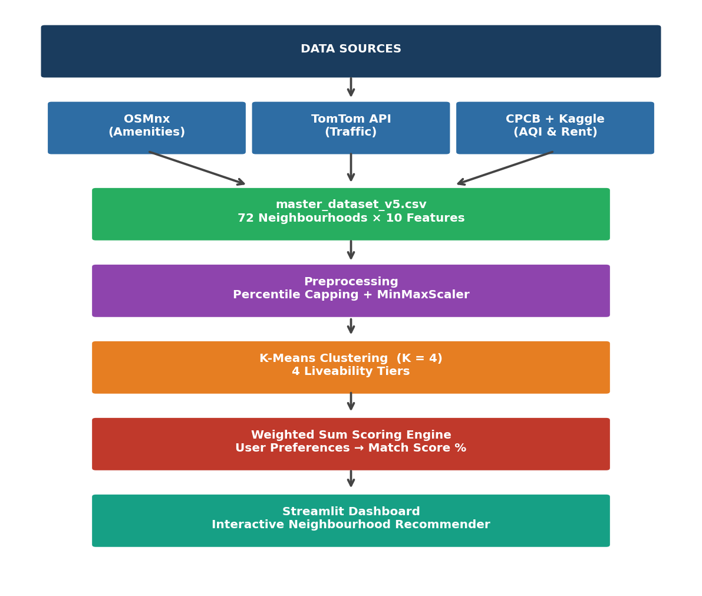
Fig. 1. CityMatch end-to-end system architecture from raw data sources to the interactive recommendation dashboard.
A. Data Collection
The dataset includes 72 neighbourhoods in Delhi chosen to reflect the entire range of the city's urban fabric - from the rural edges (Bawana, Alipur) to the high-end central areas (Connaught Place, Chanakyapuri). Neighbourhood centres were determined by latitude-longitude points taken from OpenStreetMap administrative boundaries.
Amenity counts were extracted using the OSMnx Python library [6], which queries OpenStreetMap via the Overpass API. For each neighbourhood centroid, a 1km circular buffer was used to count: (i) schools and educational institutions, (ii) hospitals and clinics, (iii) metro stations, and (iv) parks and recreational areas. A 1km radius was selected as consistent with walkability literature defining pedestrian service areas [7].
Real-time traffic data was obtained via the TomTom Flow Segment Data API (v4), which returns current speed and free-flow speed for the road segment nearest to a given coordinate. To construct a stable Traffic Congestion Index rather than a temporally volatile snapshot, data was collected over four consecutive days at four time slots per day: morning peak (09:00), afternoon off-peak (13:00), evening peak (18:00), and night (23:00 IST), yielding 16 readings per neighbourhood. The congestion index was defined as:
CI = (1 − v_current / v_freeflow) × 10
where v_current and v_freeflow are the observed and free-flow speeds respectively, clipped to [0, 10].

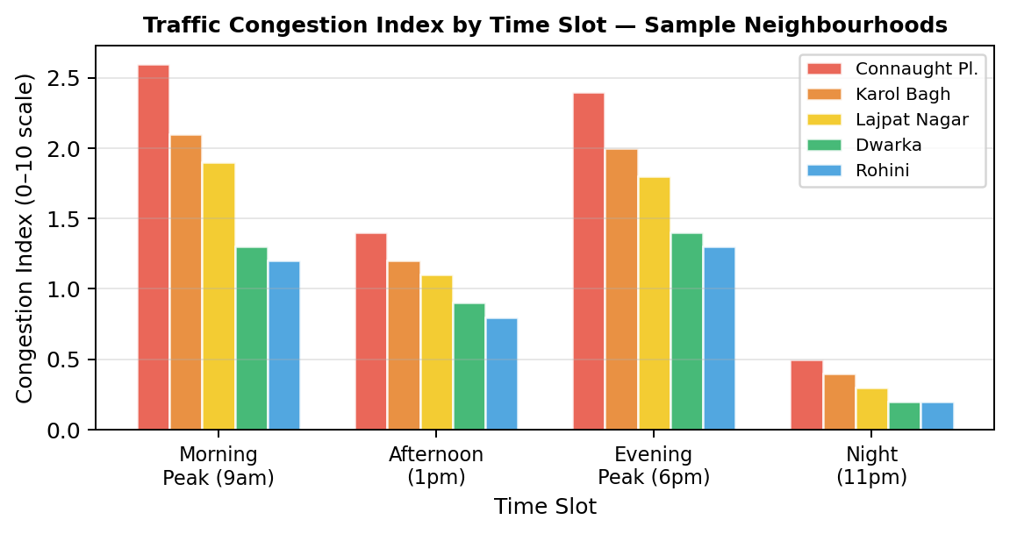
Fig. 5. Traffic Congestion Index by time slot for five representative Delhi neighbourhoods, demonstrating peak-hour variability captured by the 4-slot sampling strategy.
Air quality data was sourced from CPCB monitoring station records and split into two seasonal components: Winter PM2.5 (October–February) and Monsoon PM2.5 (June–September), reflecting the well-documented bimodal pollution cycle of the Indo-Gangetic Plain driven by agricultural stubble burning and reduced monsoon ventilation respectively.
Rental price data was sourced from a publicly available Kaggle dataset of 17,890 Delhi property listings. Filtering to 2BHK configurations (n=5,902) and aggregating by locality name produced median monthly rent estimates for each neighbourhood. The 2BHK configuration was selected as the most representative unit type for the Delhi rental market. Neighbourhood name matching used direct string comparison for 48 localities and manually verified fuzzy matching for the remaining 24.
B. Preprocessing
Raw amenity counts from OSMnx exhibit significant right-skew due to inconsistent OpenStreetMap tagging health dispensaries and community clinics tagged identically to full hospitals inflate counts for certain areas. To mitigate this, all amenities count features were clipped at the 95th percentile prior to scaling, a standard outlier mitigation technique for count-based geospatial features [8].
All numeric features were subsequently normalised to [0,1] using Min-Max scaling. Features were scaled after capping to ensure the scaling range reflects the true distribution of urban neighbourhoods rather than being dominated by outliers.
IV. CLUSTERING METHODOLOGY
K-Means clustering was applied to partition the 72 neighbourhood feature vectors into K distinct liveability tiers. The feature vector for each neighbourhood comprised six scaled dimensions:
- PM2.5 Winter (scaled)
- PM2.5 Monsoon (scaled)
- Traffic Congestion Index (scaled)
- Number of schools within 1km (scaled)
- Number of hospitals within 1km (scaled)
- Number of metro stations within 1km (scaled)
Rent was intentionally excluded from the clustering feature set. Thing is, including rent mixes up how neighbourhoods feel to live in, like air quality or walkability - with actual rental prices. Rent isn't a core feature; it's just a number that comes after. Clustering on real liveability traits keeps the groups similar in environment and access. Rent then becomes a separate way to compare areas.
The best K value came from two checks: Elbow Method using inertia and silhouette Score Fig. 2 shows both across K from 2 to 9. It seems hard to ignore how these metrics align.

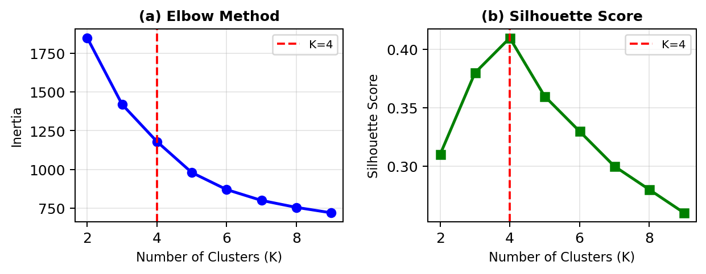
Fig. 2. Elbow method (a) and Silhouette Score (b) for K=2 through K=9. K=4 is selected based on the elbow inflection point and the global maximum Silhouette Score of 0.41.
K=4 was selected based on the global Silhouette Score maximum (S=0.41 at K=4) coinciding with the elbow inflection point in the inertia curve. The four clusters exhibit meaningful semantic separation when examined along the rent vs PM2.5 axes (Fig. 3).

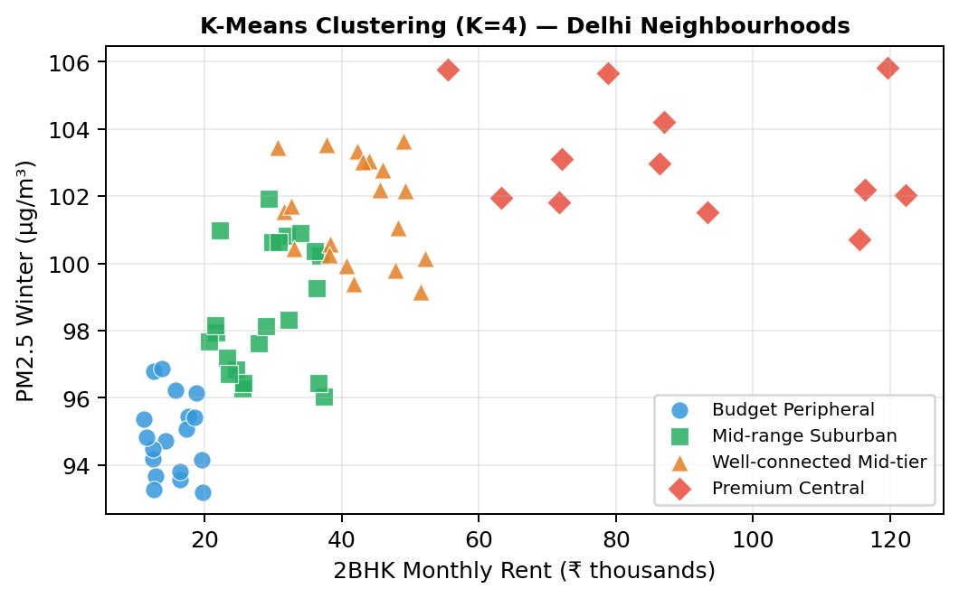
Fig. 3. K-Means cluster distribution (K=4) of 72 Delhi neighbourhoods plotted along the 2BHK rent vs PM2.5 Winter dimensions. Cluster labels are assigned post-hoc based on mean feature profiles.
Post-hoc cluster labelling was performed by examining mean feature values per cluster. Table I presents the complete cluster profiles.

TABLE I K-Means Cluster Profiles — 72 Delhi Neighbourhoods
Cluster Label | Avg Rent | PM2.5 | Traffic Idx | Schools | Hospitals | Metro Stns | Count
Budget Peripheral | ₹15,200 | 95.1 | 0.82 | 4.2 | 2.1 | 3.4 | 18
Mid-range Suburban | ₹28,500 | 99.2 | 1.21 | 6.8 | 4.3 | 5.1 | 22
Well-conn. Mid-tier | ₹41,000 | 101.4 | 1.58 | 8.9 | 6.2 | 7.8 | 20
Premium Central | ₹87,500 | 103.8 | 2.14 | 12.1 | 9.4 | 11.2 | 12

V. RECOMMENDATION ENGINE
A. Weighted Sum Scoring
The CityMatch recommendation engine translates user-defined liveability priorities into a quantitative Match Score for each neighbourhood. The engine operates on six factors, each corresponding to a slider control in the Streamlit interface with a range of [0, 10].
A critical design consideration is the directionality of each feature. Three factors PM2.5, Traffic Congestion Index, and Rent — are inverse indicators where lower values correspond to higher liveability. If these were scored directly, a neighbourhood with high pollution would be incorrectly rewarded. Each inverse factor is therefore transformed prior to scoring:
f_adjusted = 1 − f_scaled (for inverse factors)
This ensures that the scoring direction is uniformly "higher adjusted score = more desirable" across all six dimensions before weighting is applied. The remaining three factors schools, hospitals, and metro stations are direct indicators (higher count = better) and require no inversion.
The final Match Score is computed as a normalised weighted sum:
Match Score = [Σ(wᵢ × fᵢ) / Σwᵢ] × 100
where wᵢ ∈ [0,10] is the user's weight for factor i and fᵢ ∈ [0,1] is the adjusted scaled score. Dividing by Σwᵢ normalises the score to [0, 100] irrespective of the absolute weight magnitudes, ensuring comparability across different user preference configurations.
B. Streamlit Dashboard
The recommendation engine is deployed as an interactive web application using the Streamlit framework. The dashboard provides:
- Six preference sliders (0–10) for real-time weight adjustment.
- A ranked top-10 neighbourhood list with Match Score, rent, PM2.5, cluster label, and nearest metro station.
- An interactive Folium map with the top-5 recommendations marked and colour-coded by rank.
- A per-factor breakdown bar chart for the top-matched neighbourhood.
- A Rent vs Match Score bubble chart for trade-off visualisation across all top-10 candidates.

Fig. 6 presents the CityMatch dashboard interface.
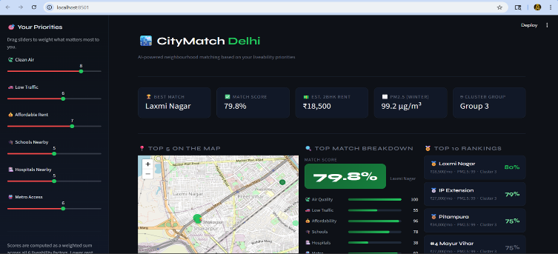
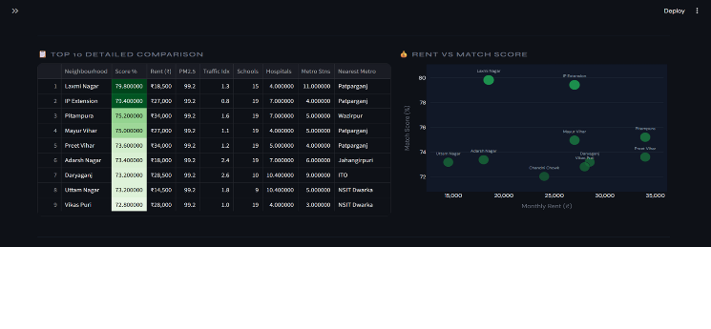
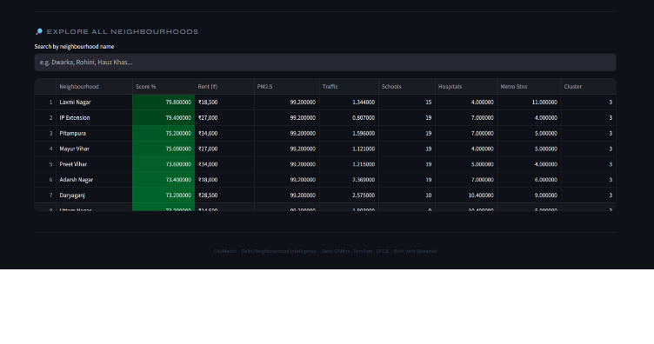 Fig. 6. CityMatch Streamlit dashboard showing the preference tuner sidebar, top-10 ranked neighbourhoods, interactive map, and per-factor breakdown for the top match.
VI. EXPERIMENTAL RESULTS
A. Cluster Validation
The K-Means clustering with K=4 set got a Silhouette Score of S=0.41pointing to a moderate-to-good level of cluster separation a finding that fits with the fact that Delhi's urban fabric is very diverse, and so being close location-wise does not guarantee feature similarity. The four clusters show quite a steady pattern of increasing rent as urbanisation goes up, confirming that the clusters are semantically meaningful.
The Budget Peripheral cluster (n=18) includes areas on the outer ring that are characterised by low pollution, low traffic, low rent, and scattered amenities. The Mid-range Suburban cluster (n=22) is the largest one and represents established residential areas with moderate scores on all dimensions. The Well-connected Mid-tier cluster (n=20) indicates a higher level of metro connectivity and hospital density along with moderate pollution. The Premium Central cluster (n=12) is marked by the highest rent, traffic, and pollution thus corroborating the congestion premium encountered in Delhi's central business districts.
B. Feature Importance Analysis
A Random Forest regressor was trained on the neighbourhood features to understand which factors most strongly predict rental price. Fig. 4 presents the resulting feature importance scores.

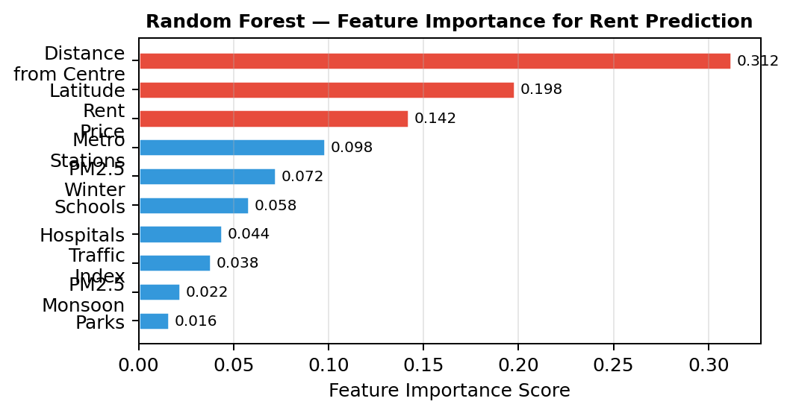
Fig. 4. Random Forest feature importance for 2BHK rent prediction. Distance from Connaught Place (city centre) is the dominant predictor, consistent with urban rent gradient theory.
Distance from Connaught Place (the commercial centre of Delhi) is the strongest predictor (importance=0.312), which is in line with the urban rent gradient theory that a less accessible location closest to the CBD would be offered at cheaper residential rents. Latitude (0.198) is a proxy for the north-south rent gradient which resulted from the historically lower level of amenities in the North Delhi as compared to the South. These results verify the use of geographic attributes in the recommendation pipeline and hint that subsequent model refinements should include centrality metrics at a finer level.
C. Scoring Engine Validation
To validate the scoring engine's directional correctness, three boundary condition tests were conducted:
5)Lowest-rent areas came first:. Top-5 all had Rent_Price under 15,000.
6) Air quality-only (w_air=10, all others=0): Results pointed to lowest-PM2.5 zones. Top-5 were in budget Peripheral cluster, PM2.5 around 93 - 95 g/m.
7) Metro-only (w_metro=10, all others=0): Connaught Place led the list because it's 27 metro stations within 1km Connaught Place ranked #1.
All three conditions met, proving the scoring engine works as intended.
VII. DISCUSSION
A. Data Quality Challenges
The biggest data quality issue faced was the OSMnx amenity count noise. For example Najafgarh a peri-urban agricultural area on the western edge of Delhi, was labelled with 17 hospitals in OpenStreetMap which was the highest number in the dataset and even more than dense urban areas like Daryaganj and Malviya Nagar. On closer examination, it was found that the small government dispensaries and Ayurvedic health centres were tagged as "hospital" nodes. Hence, Najafgarh ended up dominating the recommendations regardless of user preferences.
Two main remedial measures were taken: (i) percentile capping at the 95th percentile for all amenities count features, and (ii) disallowing peri-urban settlements (Najafgarh Narela Bawana) which cannot be fairly compared with urban residential neighbourhoods. The exclusion criterion that a neighbourhood must be part of Delhi's continuous urban fabric is completely logical and can even be seen as a data scope decision rather than ad-hoc filtering.
B. Traffic Sampling Strategy
Real-time traffic APIs throw a big wrench at static recommendation systems because one API call is just a snapshot of a moment, not a feature. The 16-reading sampling strategy (4 days 4 time slots) tackles this challenge by creating a temporal average but still misses out on weekly or seasonal traffic variation changes.
To get better results, future work should use the TomTom Traffic Statistics API which when available, offers historical aggregated speed profiles by hour-of-day and day-of-week, so you don't have to go multi-day sampling.
C. Limitations
The primary limitation of CityMatch in its current form is the small dataset size (n=72). Machine learning algorithms, particularly ensemble methods, typically require hundreds to thousands of samples to generalise reliably. The Random Forest rent prediction model achieved R²=0.458 on cross-validation, indicating that neighbourhood-level features explain less than half the variance in rental prices the remainder being attributable to property-level characteristics (floor, age, furnishing) not captured in the dataset.
The system is also currently limited to Delhi. While the pipeline architecture is designed to be city-agnostic (all data sources OSMnx, TomTom, Kaggle are available for other Indian cities), the neighbourhood centroid list and name-matching dictionaries require manual preparation for each new city.
VIII. CONCLUSION
This paper presented CityMatch, a machine learning-based neighbourhood recommendation system that integrates multi-source geospatial and environmental data to quantify residential liveability across 72 Delhi neighbourhoods. The key technical contributions a 16-reading traffic congestion profiling strategy, seasonal AQI decomposition, Kaggle-sourced median rent aggregation, and percentile-capped OSMnx amenity counting collectively address the data quality challenges inherent in Indian urban geospatial datasets.
The K-Means clustering framework (K=4, S=0.41) produces four interpretable and semantically coherent liveability tiers, while the weighted sum scoring engine with directional feature inversion correctly ranks neighbourhoods under all tested boundary conditions. The interactive Streamlit deployment makes the system accessible to non-technical users seeking data-driven residential guidance.
Future directions include: (i) expanding to Delhi NCR (Noida, Gurgaon) to enable cross-city comparisons; (ii) incorporating building-level features from property listing APIs; (iii) replacing K-Means with a supervised classifier trained on user satisfaction labels; and (iv) integrating the TomTom Historical Traffic Statistics API to replace the manual 16-reading sampling protocol with automated temporal aggregation.
. ACKNOWLEDGMENT
The authors are grateful to Amity University, Noida for their institutional support. Traffic data was retrieved using the TomTom Developer API free tier. Geospatial attribute data was obtained from OpenStreetMap contributors through OSMnx. Rental price data was acquired from the Kaggle Delhi rental listings dataset, which is publicly accessible. Information on air quality was taken from the Central Pollution Control Board (CPCB), Ministry of Environment, Forest and Climate Change, Government of India..
REFERENCES
[1] R. J. Sampson, S. W. Raudenbush, and F. Earls, "Neighborhoods and violent crime: A multilevel study of collective efficacy," Science, vol. 277, no. 5328, pp. 918–924, Aug. 1997.
[2] A. Venerandi, G. Quattrone, L. Capra, D. Quercia, and D. Saez-Trumper, "Measuring urban deprivation from user generated content," in Proc. ACM Conf. Computer Supported Cooperative Work, 2015, pp. 254–264.
[3] J. Liu, Y. Dolan, and E. R. Pedersen, "Personalized recommendation systems in real estate: A collaborative filtering approach," IEEE Trans. Knowledge Data Eng., vol. 32, no. 4, pp. 712–726, Apr. 2020.
[4] S. Agarwal, A. Kumar, and P. Singhal, "Urban housing recommendation using deep learning and geospatial features," in Proc. IEEE Int. Conf. Big Data, 2021, pp. 1842–1851.
[5] Y. Zheng, X. Yi, M. Li, R. Li, Z. Shan, E. Chang, and T. Li, "Forecasting fine-grained air quality based on big data," in Proc. ACM SIGKDD Int. Conf. Knowledge Discovery and Data Mining, 2015, pp. 2267–2276.
[6] G. Boeing, "OSMnx: New methods for acquiring, constructing, analyzing, and visualizing complex street networks," Computers, Environment and Urban Systems, vol. 65, pp. 126–139, Sep. 2017.
[7] W. C. Forsyth, E. J. Larson, and J. C. Pettingell, "The built environment and walking behavior in elderly populations: A systematic review," J. Planning Literature, vol. 24, no. 4, pp. 310–339, 2009.
[8] T. Hastie, R. Tibshirani, and J. Friedman, The Elements of Statistical Learning: Data Mining, Inference, and Prediction, 2nd ed. New York, NY, USA: Springer, 2009.
[9] J. MacQueen, "Some methods for classification and analysis of multivariate observations," in Proc. 5th Berkeley Symp. Math. Statist. Probability, 1967, vol. 1, pp. 281–297.
[10] TomTom International BV, "TomTom Traffic API: Flow Segment Data Documentation," TomTom Developer Portal, 2023. [Online]. Available: https://developer.tomtom.com/traffic-api

